|  |  |  |  |
| --- | --- | --- | --- |
| **Ex. No. 03** | **MACROPROCESSOR** | | |
| Date of Exercise | ____________ | Date of Output Verification | _____________ |

**Question**

Write a program to perform the functions of macro processor with function macro and execute the output of the macro processor program.

**Program**

import java.io.*;

import java.util.*;

public class CompilerLabExp3MacroProcessor {

//UR12CS135 - William Scott - Exp 3 - Macro Processor

public static BufferedReader br, broutput, brinput;

public static BufferedWriter bw;

public static Scanner in = new Scanner(System.in);

public static String line = "", t = "";

public static ArrayList definitions = new ArrayList(), values = new ArrayList();

public static int count = 0;

public static void main(String[] args) throws FileNotFoundException, IOException {

System.out.println("UR12CS135 - Macro Processor");

br = new BufferedReader(new FileReader("..\\Exp 3 - MacroProcessor Input File.txt"));

brinput = new BufferedReader(new FileReader("..\\Exp 3 - MacroProcessor Input File.txt"));

broutput = new BufferedReader(new FileReader("..\\Exp 3 - MacroProcessor Output File.txt"));

bw = new BufferedWriter(new FileWriter(new File("..\\Exp 3 - MacroProcessor Output File.txt")));

bw.flush();

showinputfile();

while (!(line = br.readLine()).contains("main")) {

if (line.contains("#define")) {

store(line);

} else {

bw.newLine();

bw.write(line);

}

}

bw.write(line);

bw.newLine();

while ((line = br.readLine()) != null) {

replacevalues(line);

}

bw.close();

showvalues();

showoutput();

}

public static void store(String a) {

t = a;

String[] s = new String[3];

s = t.split(" ", 3);

if (s[2].startsWith("{")) {

s[2] = s[2].substring(1, s[2].length() - 1);

s[1] += ';';

} else {

s[2] = s[2].substring(0, s[2].length() - 1);

}

definitions.add(s[1]);

values.add(s[2]);

count++;

}

public static void showvalues() {

System.out.println("\n\n-------Stored Values----------");

for (int i = 0; i < count; i++) {

System.out.println(definitions.get(i) + " " + values.get(i));

}

}

public static void replacevalues(String a) throws IOException {

for (int i = 0; i < count; i++) {

if (a.contains((String) definitions.get(i))) {

a = a.replace((String) definitions.get(i), (String) values.get(i));

}

}

bw.write(a);

bw.newLine();

}

public static void showoutput() throws IOException {

System.out.println("\n\n--------Output File----------");

String a;

while ((a = broutput.readLine()) != null) {

System.out.println(a);

}

}

public static void showinputfile() throws IOException {

System.out.println("\n\n--------Input File----------");

String a;

while ((a = brinput.readLine()) != null) {

System.out.println(a);

}

}

}

**Input**

*Exp 3 - MacroProcessor Input File.txt*

#include<iostrem.h>

#include<stdio.h>

#define pi 3.14;

#define px 5;

#define add() {cout<<"Hello";}

void main ()

{

cout<<pi;

cout<<px;

add();

}

**Output**

*Exp 3 - MacroProcessor Output File.txt*

#include<iostrem.h>

#include<stdio.h>

void main ()

{

cout<<3.14;

cout<<5;

cout<<"Hello";

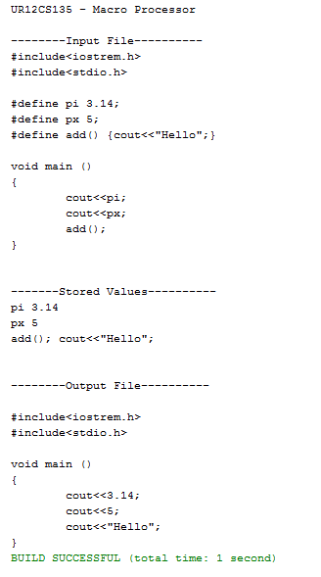}



**Result**

Macroprocessor for ‘C++’ language is successfully implemented.

[Signature of the Staff In-charge]

Name of the Staff In – charge: Mr. Jeban Chandir Moses

Date: ____________